U9 U11 passing BASA
Category: Technical: Passing & Receiving Difficulty: Moderate
partner passing (10 mins)
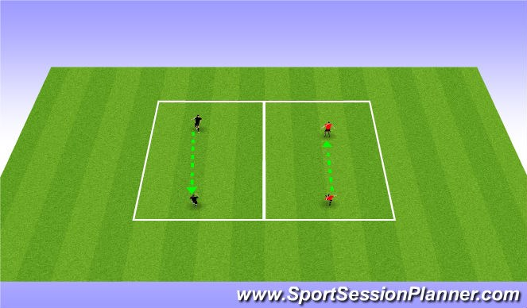
2 touch passing
make players be on the balls of their feet, ready to receive the ball Player must be ready to receive the ball with one foot pass with the other
Ball must be a half a step in front of passer must follow through the ball.
group of 3 passing (10 mins)
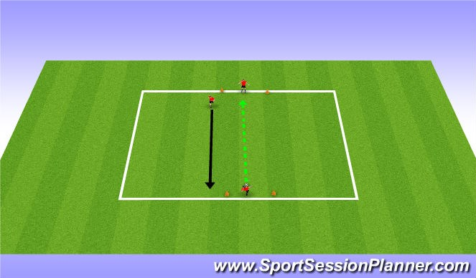
Group of 3 passing
Players must complete a pass in a 4yd goal
This gives the players a target to be comfortable completing a pass in
Players must follow their pass and be ready to receive the ball on the other side
Coaching points:
Inside of foot
Follow through the ball
Keep hips facing target.
4v1 possession (15 mins)
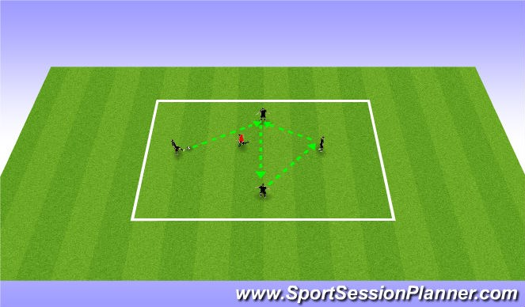
4v1 Possession
Players play keep away from defender
Possessing players can move in a 20x20 grid to receive the ball Defender plays for 2 minutes strait.

cone attack (25 mins)
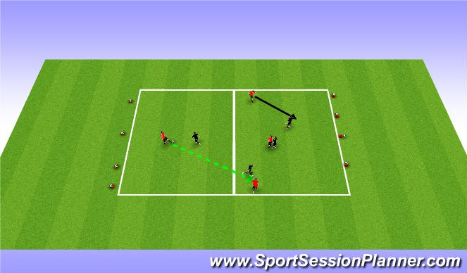
Teams start with 4 cones and a ball on each cone (4v4 5v5)
The teams are trying to attack the cones with the ball and knock the ball off the cone
Team who knocks all the balls off the cone wins.

